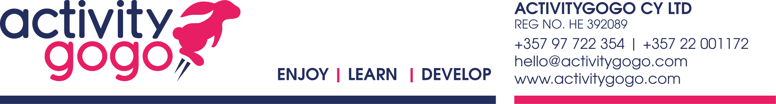

Package Listing Application Form

The details provided on this form will be used to create and list your services for sale on activitygogo.com. For each package a digital voucher will be created that users will be able to purchase online in order to redeem it, in exchange for the provided services as defined on the listed package.

For listing different services, please complete a new form for each package.

Once we receive your request, we will contact you to confirm all the provided details before making your package live on the activitygogo online shop.

Please complete the following form as best as you can and send it via email to: hello@activitygogo.com

IMAGES
In your email please include at least 2 photos per package (attachments), which we can use to promote this service. Please make sure you only send us photos for which you have the copywrites / consent to use. By sending us these photos you grant us the right to use them and distribute them in any way we deem appropriate in order to promote your listed package and services.

For any questions you can contact us via email or phone.
(hello@activitygogo.com | +357 97 722 354 | 357 22 001 172)

VENDOR DETAILS

FULL NAME:
CONTACT PHONE NUMBERS:
Mobile:
Landline:
CONTACT EMAIL:
YOUR ACTIVITYGOGO PROFILE LINK:

PACKAGE DETAILS

Is this package going to be exclusive to activitygogo.com? YES NO

(To list your services for sale on activitygogo.com we ask that you offer at least one package that is going to be exclusive to Activitygogo. You can create an exclusive package by adding special benefits and services as part of a package or by offering a package you already sell at a lower price. Exclusive packages tailored made for beginners have much higher priority in promoting them through our website, social media and newsletters.)

PACKAGE TITLE:

DESCRIPTION:

WHAT IS INCLUDED:

WHAT IS NOT INCLUDED:

WHAT TO BRING:

DRESS CODE:

SPOKEN LANGUAGES:

Include only the languages in which you can provide the activities you offer.

PRICING – (In € with VAT included):

REDEEM INSTRUCTIONS

VOUCHER EXPIRATION TYPE (Choose ONE Type)

A. BASED ON PURCHASE

VOUCHER EXPIRES 3 months / 6 months / 12 months AFTER PURCHASE.
OR

B. SPECIFIC DATE

VOUCHER VALID FROM: DD/MM/YYYY

VOUCHER EXPIRES ON: DD/MM/YYYY

AVAILABILITY
Please include the exact Days and Times that will be available to the user to request a booking after purchasing their voucher. Please also include the months during which this service is available and/or unavailable.
>

PARTICIPANT GUIDELINES (SUITABILITY & RESTRICTIONS)
Who is this suitable for? (e.g. exact ages, experience level, etc) Who is it not suitable for? Please include any age/weight/health or other restrictions that might apply.
>
REDEEM INSTRUCTIONS
Please enter instructions for the customer on what exactly they need to do to confirm their booking after purchasing their voucher. For Example: To book your time slot please text or call 99****** (Mon-Sat 9am-5pm) at least 1 day in advance, with your preferred date & time.
>
LOCATION
Please write the address where the activity can be redeemed. If it can be redeemed in multiple locations, please include all options. Also please ensure that your location is correctly set on your profile page by zooming in the map pin.
>

--------------------------------------------------- END --------------------------------------------------

